|  |  |  |  |  |  |  |  |  |
| --- | --- | --- | --- | --- | --- | --- | --- | --- |
| **Assignment - 4**   |  |  | | --- | --- | | Assignment Date | 22 October 2022 | | Student Name | ANN EDWIN JOSHWA.M | | Student Roll Number | 95071914010 | | Maximum Marks | 2 Marks |   **Question-1:**  Write code and connections in wokwi for ultrasonic sensor.Whenever distance is less than 100 cms send “Alert” to ibm cloud and display in device recent events.  **Solution:**  // Pins  const int TRIG_PIN = 7; const int  ECHO_PIN = 8;  // Anything over 400 cm (23200 us pulse) is "out of range" const unsigned int MAX_DIST = 23200; void setup() {  // The Trigger pin will tell the sensor to range find pinMode(TRIG_PIN,  OUTPUT);  digitalWrite(TRIG_PIN, LOW);  //Set Echo pin as input to measure the duration of  //pulses coming back from the distance sensor pinMode(ECHO_PIN, INPUT);  // We'll use the serial monitor to view the sensor output Serial.begin(9600); } void loop()  {  unsigned long t1; unsigned long t2; unsigned long pulse_width; float cm; float inches;  // Hold the trigger pin high for at least 10 us |

|  |
| --- |
| digitalWrite(TRIG_PIN, HIGH); delayMicroseconds(10); digitalWrite(TRIG_PIN, LOW);  // Wait for pulse on echo pin while ( digitalRead(ECHO_PIN) ==  0 );  // Measure how long the echo pin was held high (pulse width) // Note: the micros() counter will overflow after ~70 min t1 = micros();  while ( digitalRead(ECHO_PIN) == 1); t2 = micros(); pulse_width = t2 - t1;  // Calculate distance in centimeters and inches. The constants // are found in the datasheet, and calculated from the assumed speed //of sound in air at sea level (~340 m/s). cm = pulse_width / 58.0; inches = pulse_width / 148.0;  // Print out results  if ( pulse_width > MAX_DIST ) { Serial.println("Out  of range"); } else {  Serial.println("*******************************");  Serial.print("The Measured Distance in cm : "); Serial.println(cm);  if(cm<100){  // while(true){  Serial.println("Alert!!");  // } }  Serial.print("*******************************"); }  // Wait at least 1000ms before next measurement delay(1000);  } |

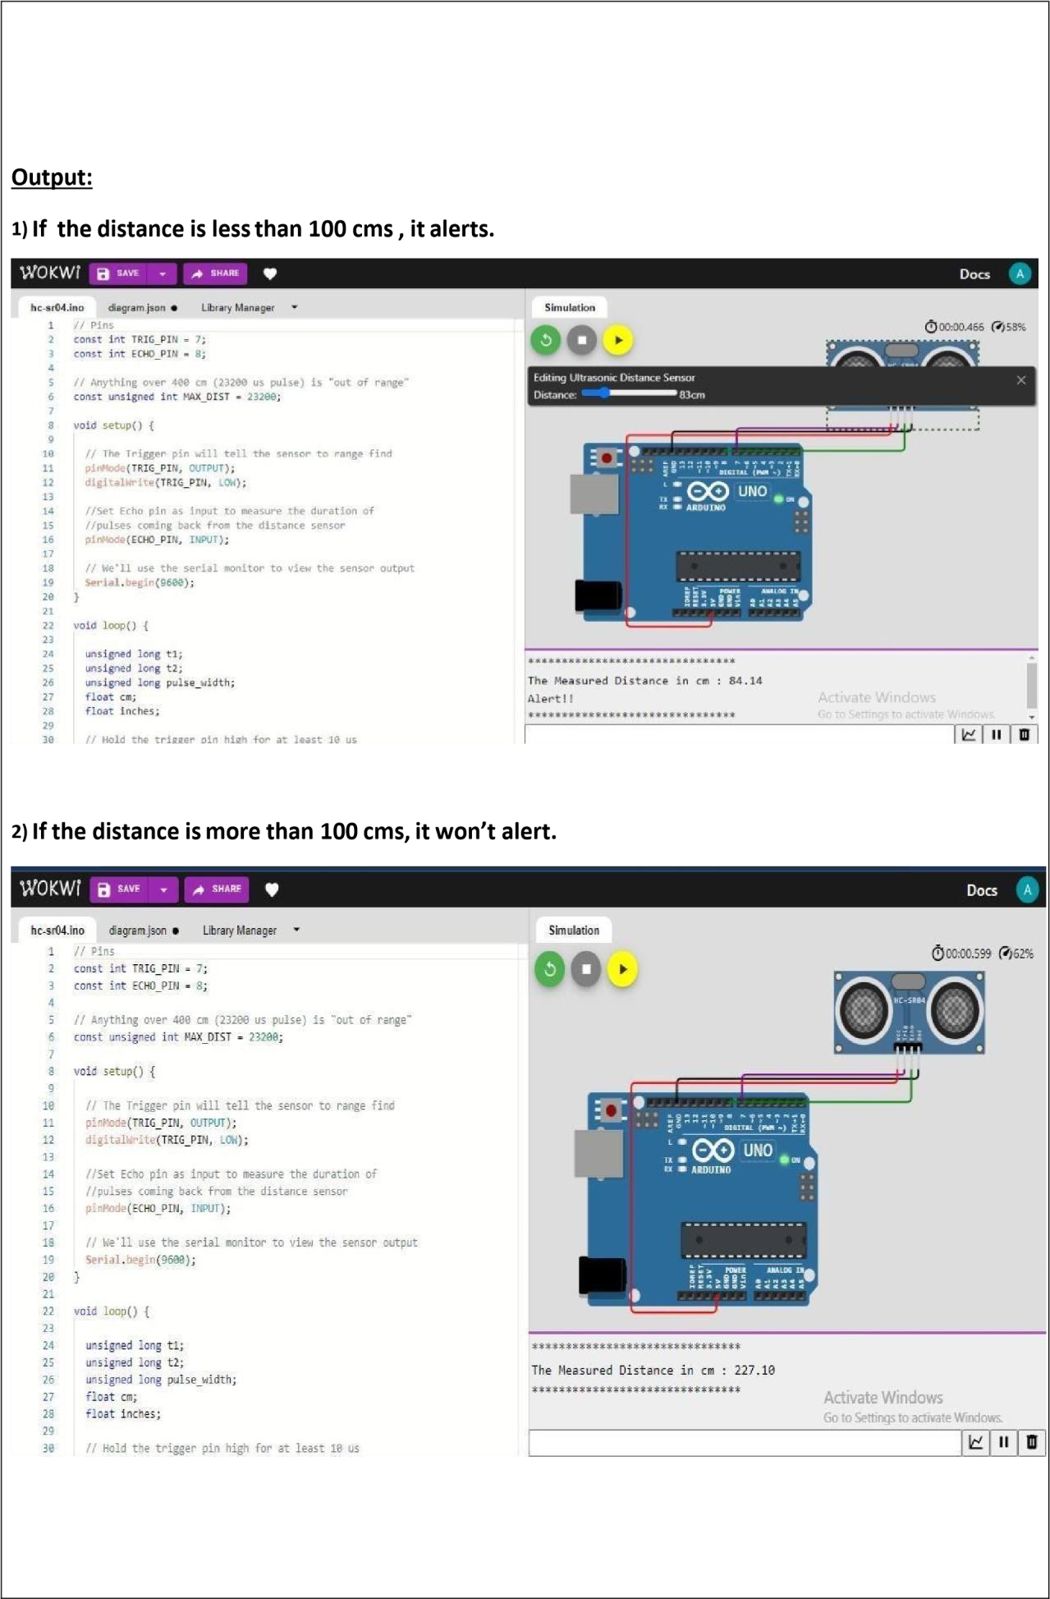

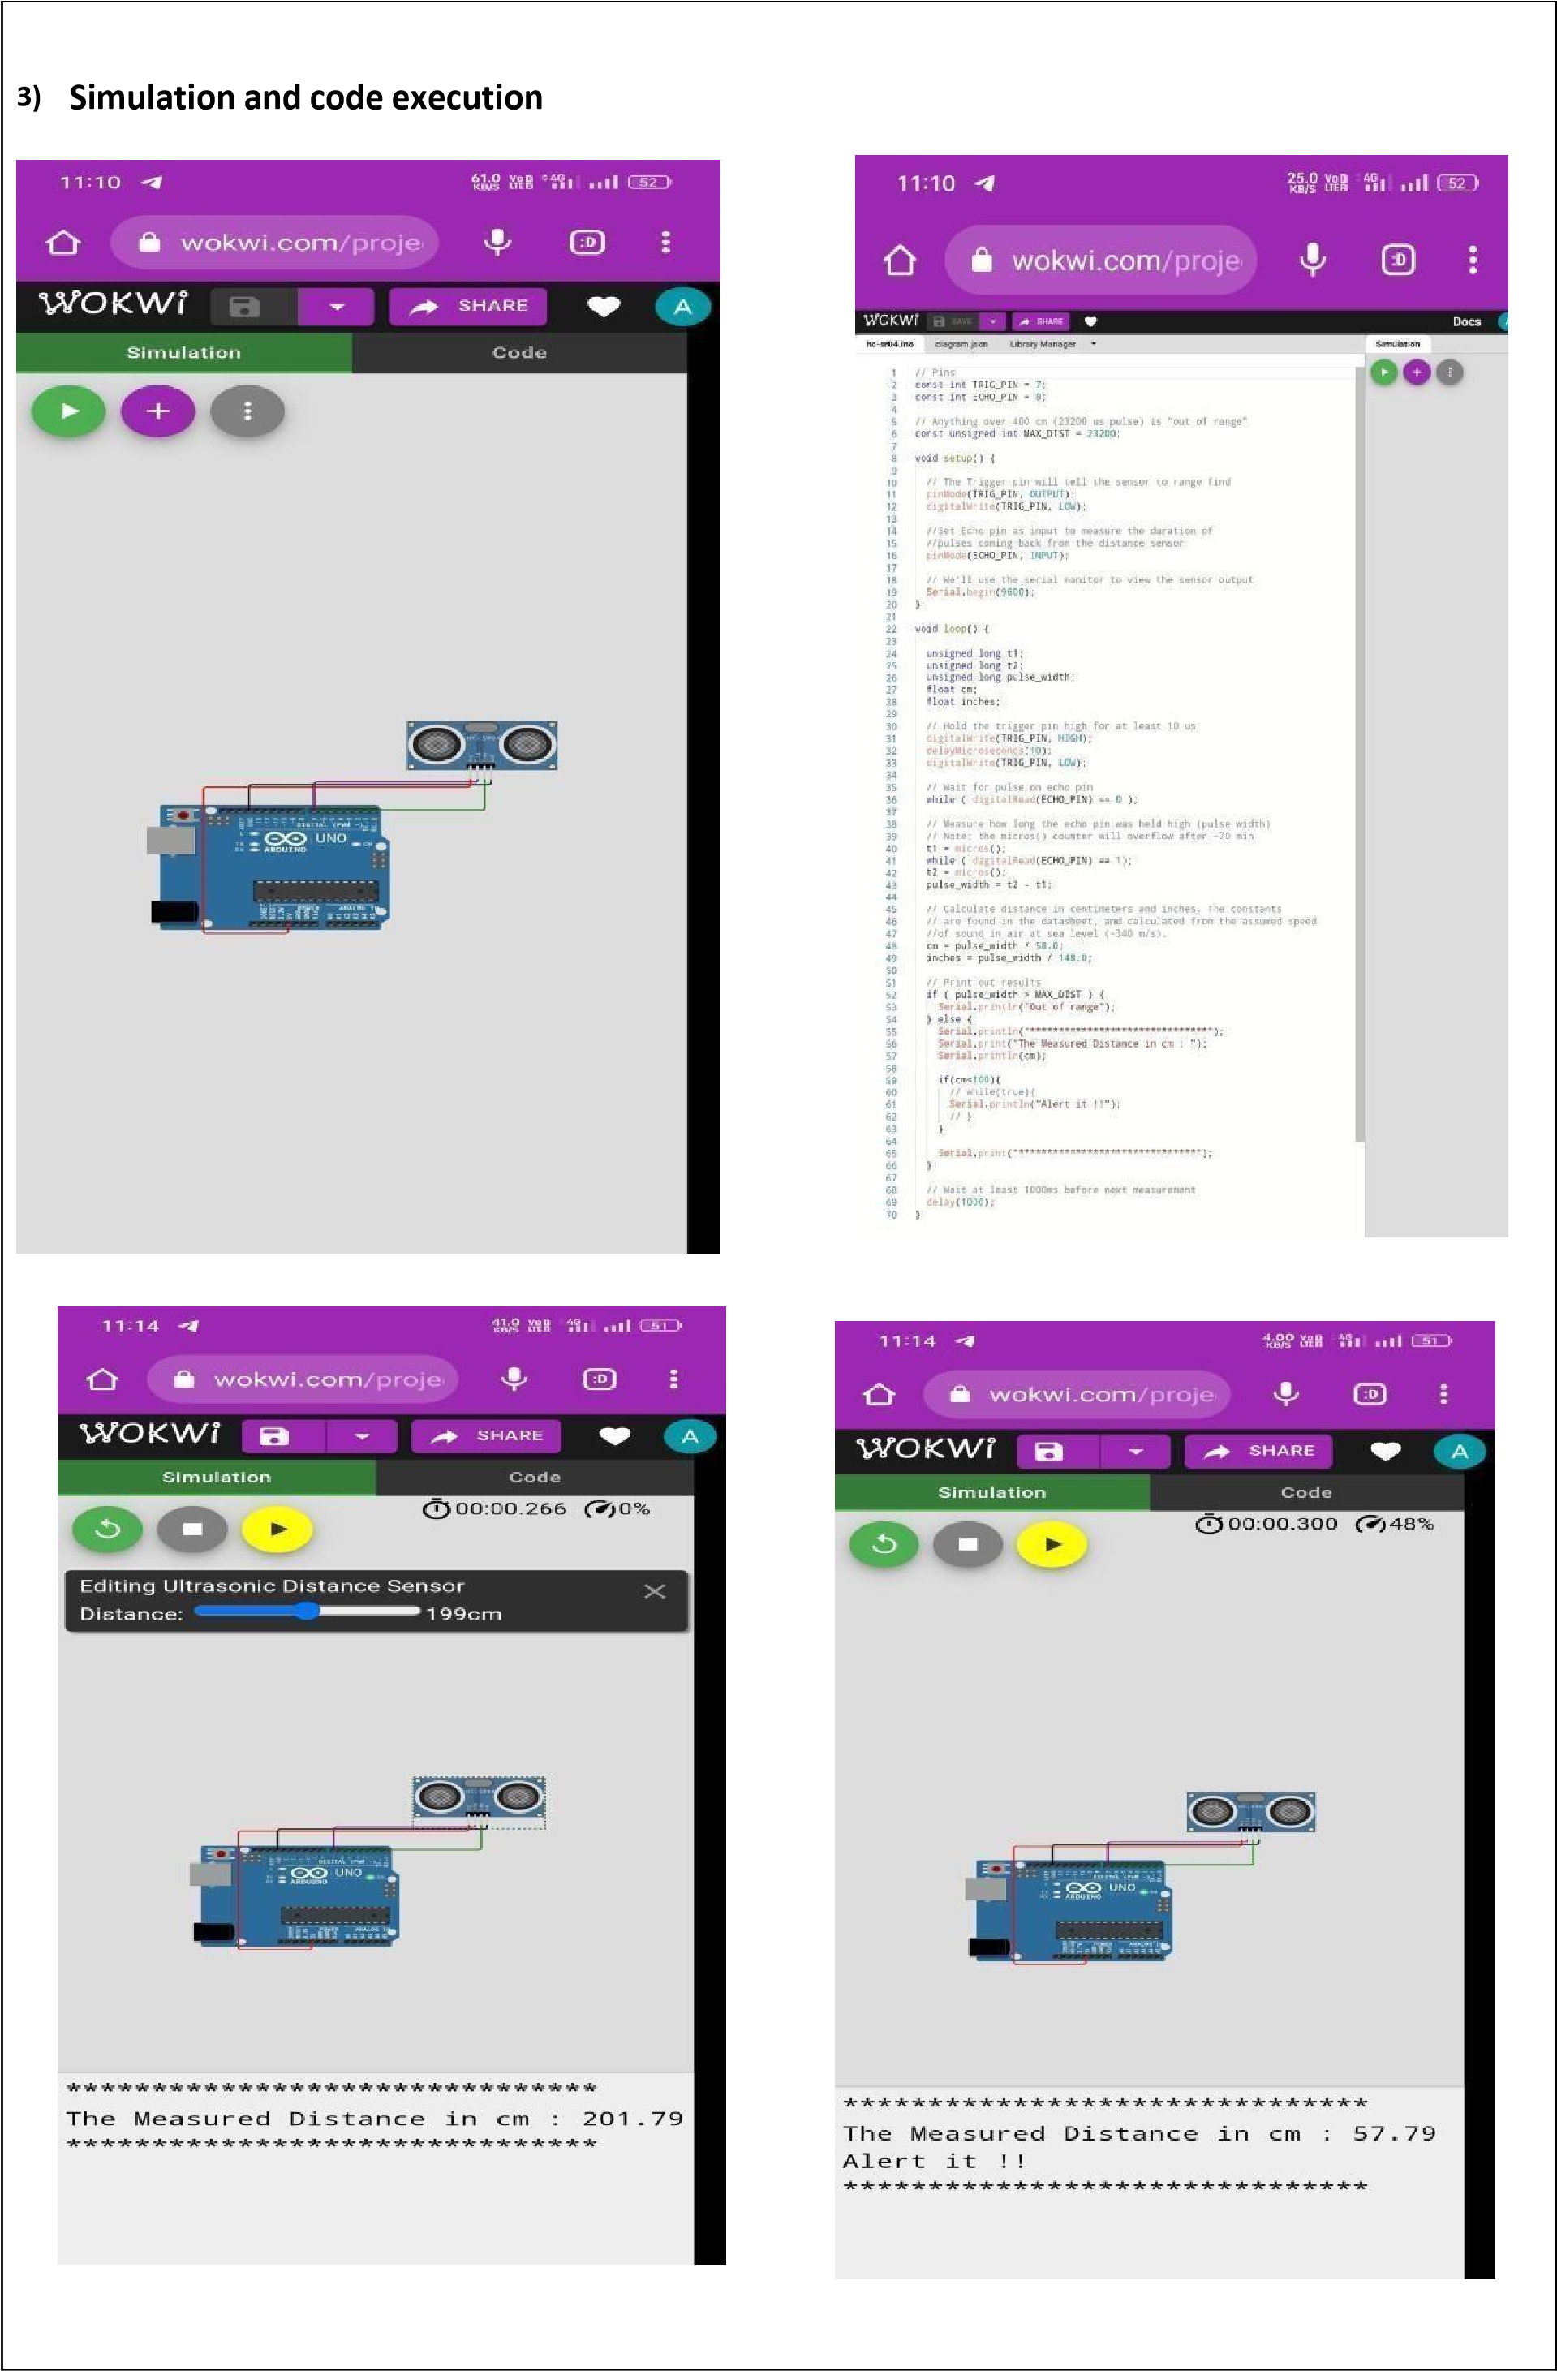

|  |
| --- |
| **Project Link:**  https://wokwi.com/projects/new/arduino-uno. |